**60. Using repo name**

--- tree

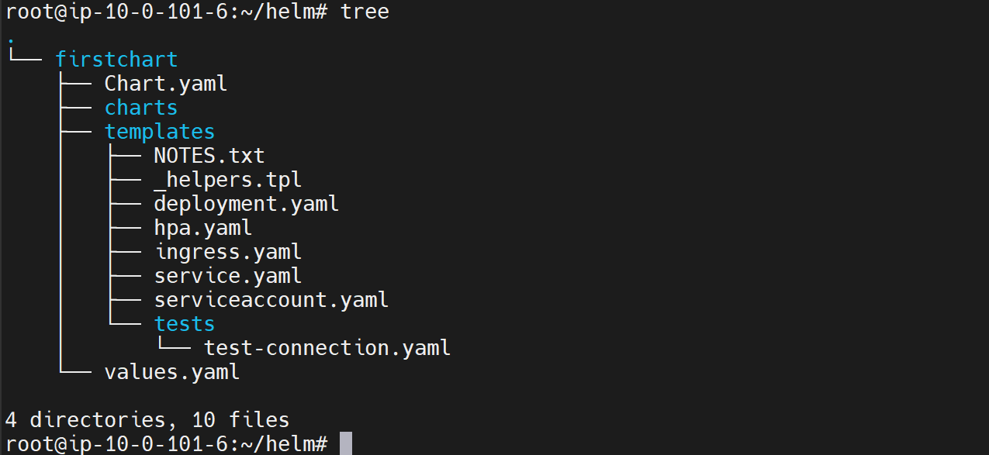

--- cat Chart.yml

apiVersion: v2

name: firstchart

description: A Helm chart for Kubernetes

# A chart can be either an 'application' or a 'library' chart.

#

# Application charts are a collection of templates that can be packaged into versioned archives

# to be deployed.

#

# Library charts provide useful utilities or functions for the chart developer. They're included as

# a dependency of application charts to inject those utilities and functions into the rendering

# pipeline. Library charts do not define any templates and therefore cannot be deployed.

type: application

# This is the chart version. This version number should be incremented each time you make changes

# to the chart and its templates, including the app version.

# Versions are expected to follow Semantic Versioning (https://semver.org/)

version: 0.1.0

# This is the version number of the application being deployed. This version number should be

# incremented each time you make changes to the application. Versions are not expected to

# follow Semantic Versioning. They should reflect the version the application is using.

# It is recommended to use it with quotes.

appVersion: "1.16.0"

dependencies:

  - name: mysql

    version: ">= 8.8.0 and < 9.0.0"

    repository: "https://charts.bitnami.com/bitnami"

--- **note** - When we define a dependency, we provide the repository url. we can also use the name of the repository you have added using Helm Repo Command here. For that, you will have to use @ whatever name you have given to the repository.

dependencies:

  - name: mysql

    version: ">= 8.8.0 and < 9.0.0"

    repository: "@bitnami"

--- note - it is recommended that we use the url's because across environments will have to have this bitnami named repository added locally using helm. If not, that will fail.